Zombie King

Game Design Document

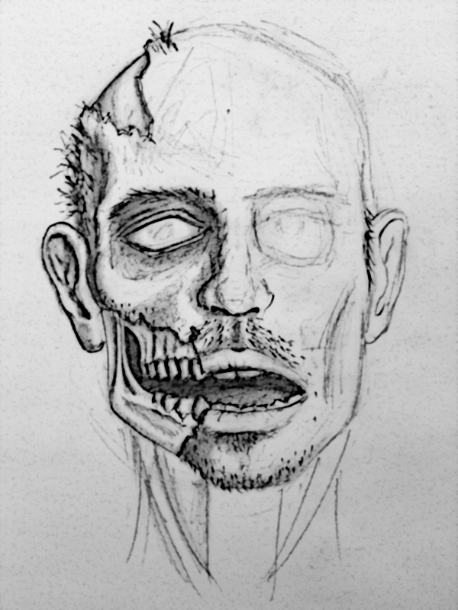

*Joe Ennever*

*Daniel Lasry*

*Miles Lennon*

*Benjamin Ludman*

*Conor Russomanno*

*Jordan Schau*

Game Summary 5

Concept 5

Overview 5

Genre & Key Game Descriptors 5

Audience 6

Platform 6

Access 6

Story 6

Visual Aesthetics 7

Concept Art 7

Palette & Sprites 8

The World 9

Effects 9

Game Flow 11

Session 11

Start Screen 11

Game Loop 13

Player Pauses 15

Player Actions 17

Movement 17

Walking 17

Rotating 17

Attack 17

Control 17

Visual 17

Zombie Horde Control 18

Interaction with Horde and Enemies 19

Game State Control 19

Zombie Horde 20

Overview 20

Zombie Horde Rules and Attributes 20

States 20

**Visual** 21

**Attack Range** 22

**Damage** 22

**Enemy Death** 22

Visual 22

Health Indicator 22

Corpse 23

Audio 23

Attack 23

Being Attacked 23

Death 23

Enemies 24

Overview 24

General Enemy Rules & Attributes 24

Purpose 24

Method of Dealing Damage 24

Audio 24

Visual 24

Engagement State 26

Velocity 28

Path Finding & Walls 28

Interaction with Other Enemies 28

Damage Absorption 28

Visual Cue 28

Definitions of Enemy Types 28

Overview 28

Waves 30

Overview 30

Spawning Zones 30

Difficulty Progression 31

Intra-Wave Difficulty Progression 31

Inter-Wave Difficulty Progression 31

Scoring System 32

HUD 33

Overview 33

HUD Elements 33

Environment Features 34

Overview 34

Map features 34

Camera 35

Audio Assets 36

Cop Audio 36

Takes Damage 36

Death 36

Zombie Audio 36

Attack 36

Takes Damage 36

Death 37

Spawn 37

Visual Assets 38

Technical Design Overview 42

Overview 42

Big Issues 42

Collisions 42

Path Finding and Obstacle Avoidance 42

# Game Summary

## Concept

### Overview

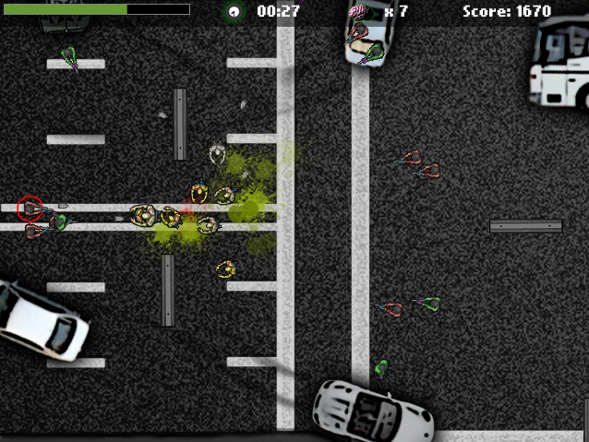

Zombie King challenges the player to:

* Survive waves of attack from humans trying to eradicate infection
* Spread infectious disease to increase the zombie horde
* Direct and manage a zombie horde to thwart the human resistance

The objective of the game is to maximize total score.

### Genre & Key Game Descriptors

* Casual
* Action
* Third-person, top-down perspective

### Audience

* Gender: Male
* Age: 14-35
* Games engagement: Plays at least 2 hours of games per week
* Gamer type: Casual.
  + Low effort, casual player loosely exploring flash game portals
  + High effort, intense casual player competitive in leaderboards and personal best scores

### Platform

Flash. Please review the Technical Documents for more details.

### Access

Web <http://www.bit.ly/zombieking>

## Story

Play as a zombie and give humans their toughest test yet!

A nameless zombie (player) is the last zombie alive after humans valiantly banded together to nearly eradicate the infectious disease. Families around the world are once beginning to feel safe. But what the innocent humans don't know is that the last zombie alive has never-before-seen intelligence and abilities to forge their most difficult test yet. The last zombie standing between humans and their safety not only has the ability to spread the infection, but also strategically direct and manage those it infects.

## Visual Aesthetics

### Macintosh HD:Users:crussoma:Desktop:ZOMBIE_KING:Game Art:Lightened:2sickFACE.pngConcept Art

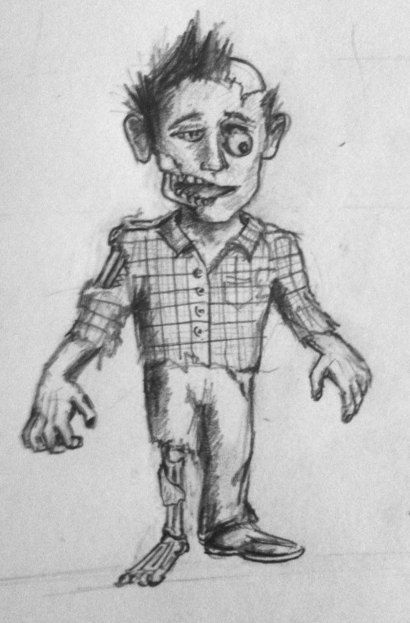

In the original concept the visual aesthetic direction was friendlier and more human. As our game evolved so did the art. As you can see, the picture on the right (above) has a much more realistic and lifeless feel, which mimics the shift in our game direction towards a more intense, dark, and action-oriented game. This contrasts heavily from the original concept (above left) where the zombie was benevolent and possessed certain human-like characteristics.

### Palette & Sprites

**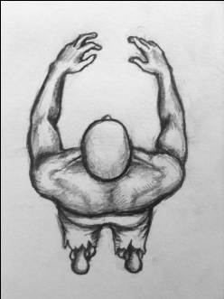 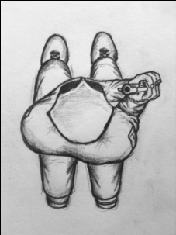** **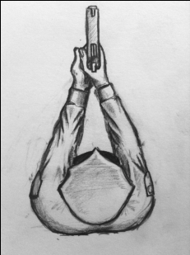** **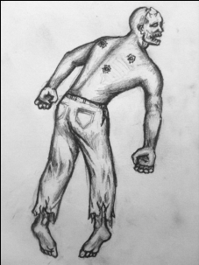**

### Macintosh HD:Users:crussoma:Desktop:ZOMBIE_KING:Enemy Pawn:PawnEasy_576x96.png

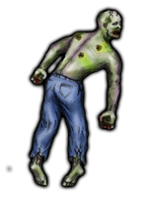The four sketched images in the beginning of this section were the root images used to develop all of the sprite graphic art in this game. The other images in this section are the final sprite files that were developed in Photoshop and used in the actual game. These files were manipulated directly from the original artwork.

Throughout the development of the game, there was a lot of debate about the color palette that would be used for the zombies and the cops. The team came to a consensus that the zombie should appear to have rotting flesh and eventually a pale green primary color was decided upon. Because the resolution of the images was being reduced so drastically to be input into the game, it was important that the final graphic designs had very sharp edges and the complimentary colors (red in the case of the zombie) were used to emphasize shadows and variations in contour.

For the cops, a generic blue uniform was used for the most basic enemy. Eventually the basic blue police officer was modified to have varying colors to distinguish between different difficulties of enemies. The different cops can be seen in the screenshots throughout the rest of this report.

### The World

The world is a desolate urban wasteland that has been ravaged by zombies. The humans have formed resistance forces and are attempting to eradicate the final remnants of the zombies. For more information, see the environment section.

**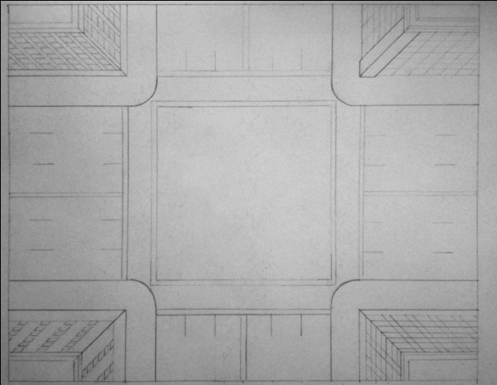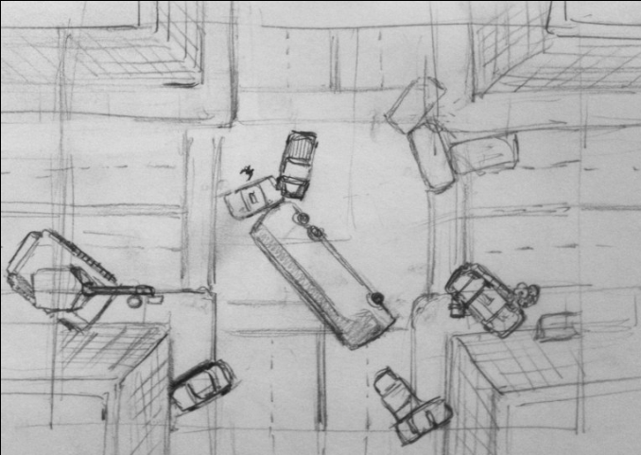**Concept and Final Art for **the** World:

### Macintosh HD:Users:crussoma:Desktop:ZOMBIE_KING:Level:levelFINAL.png

### Effects

In combat, several effects are applied to inform the player that the state of an enemy or character has changed. For example, when the player is shot, blood splatters in a specific color to indicate that a shot was absorbed. Likewise, when a member of the zombie horde is shot, blood splatters in a different color to indicate that a minion zombie absorbed a shot.

Please view the Player Actions, Enemies, Zombie Horde, and HUD sections of the document for more details on effects.

# Game Flow

## Session

## [https://sites.google.com/site/zombiekingproject/_/rsrc/1292611392928/home/game-flow/sessionflow.png?height=358&width=400](https://sites.google.com/site/zombiekingproject/home/game-flow/sessionflow.png?attredirects=0)

When the player presses "Start," a session begins. A player can play multiple rounds within each session. A round ends when the player dies. The next round begins when the player presses "Play Again." A session ends when the window is closed or the player navigates to a different URL.

## Start Screen

The initial screen contains a start button, a list of player controls and a key identifying the different types of enemies and zombies. The key will show each type of enemy along with a short description.   It will also show the art for zombies in the zombie horde.  This key will show a zombie at high, medium and low health as well as a short description.

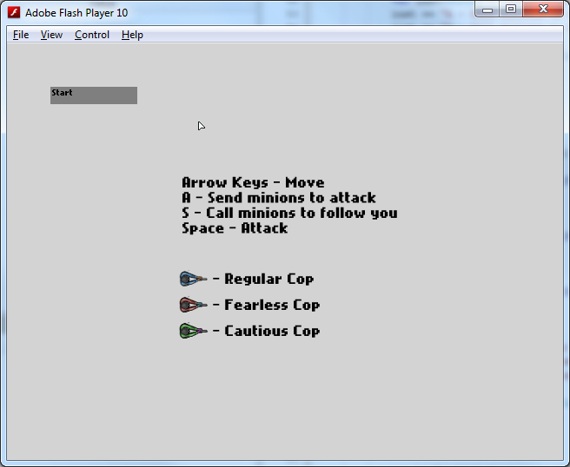

## Game Loop

## [https://sites.google.com/site/zombiekingproject/_/rsrc/1292611435171/home/game-flow/RoundFlow.png](https://sites.google.com/site/zombiekingproject/home/game-flow/RoundFlow.png?attredirects=0)

The player starts in the center of the environment.

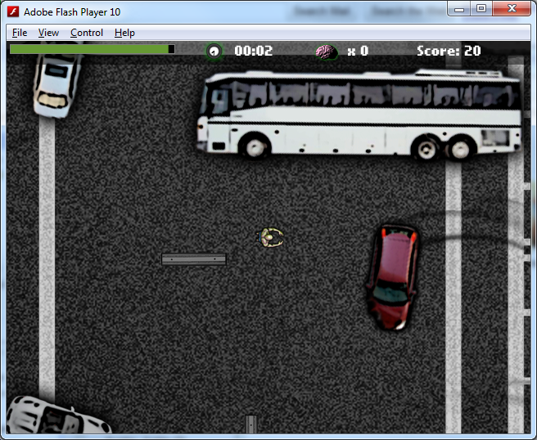

Simultaneously enemies in the first wave are spawned and begin to move towards the zombie king.

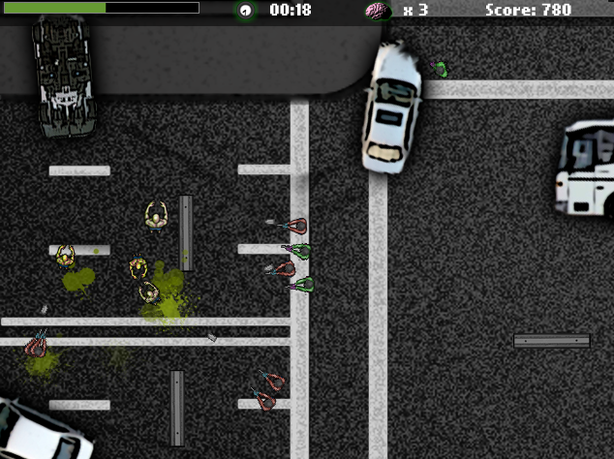

The player engages in combat with the enemies.

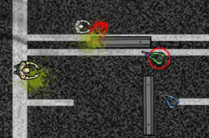

The goal of the player is to achieve the score possible before his health reaches zero. At the end of each round, the player is presented an end game screen containing his scoring metrics for that round and his best from the session. The scoring metrics are:

* Brains eaten by the player
* Brains eaten by the zombie horde
* Survival time
* Total Score

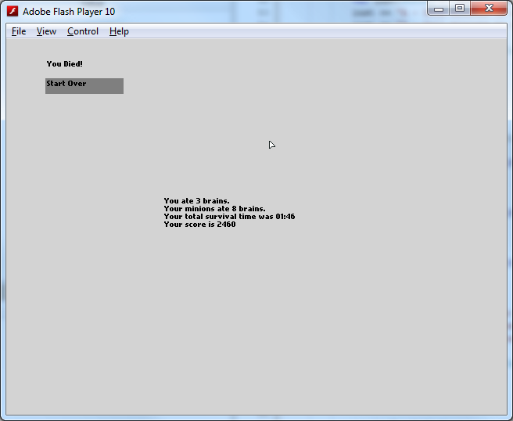

## Player Pauses

The player can pause the game at any time by pressing "P."

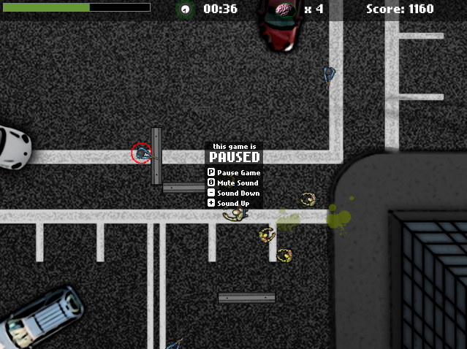

# Player Actions

## Movement

### Walking

When the player presses the up directional button, the zombie king sprite moves in the direction the zombie king sprite is facing. Likewise, when the player presses the down directional button, the zombie king sprite moves in the opposite direction the zombie king sprite is facing. The walking speed is 60 pixels per second.

While the player presses the up or down directional buttons, the zombie king sprite animates at six frames per second, cycling through three different frames.



### Rotating

When the player presses the left or right directional buttons, the zombie king sprite rotates counter-clockwise or clockwise, respectively. The speed of rotation is 300 degrees per second and the current walking animation frame is rendered at the current angle.

## Attack

### Control

The player attacks by pressing the space bar. The maximum attack rate is two attacks per second.

### Visual

When the player presses the space bar (on key down), the zombie king sprite animates through three frames at seven frames per second.



**Audio**

When the player presses the space bar (on key down), the attack audio file plays once.

**Attack Range**

Damage is dealt equally to every enemy intersecting with the zombie king's attack box when the player attacks. The attack box is an invisible 32 x 42 rectangle positioned in front of the zombie king sprite.

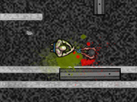

**Damage**

With each attack, the player deals 25 damage to all enemies intersecting with the attack box.

**Enemy Death**

When an enemy is killed, the player recovers 40 health, and new zombie is spawned at the enemy's location.

## Zombie Horde Control

The player controls the zombie horde in three ways:

* Dispatch zombie (A key): When the player presses 'A', the zombie nearest to the player is dispatched to attack the selected enemy.
  + Enemy selection: An enemy is selected depending on where the player is facing. The enemy that has the smallest angular disparity from the player's line of sight will be highlighted.
  + If all zombies are dispatched, no enemy can be selected as a target.
* Send Horde (S key): When the player presses 'S', each zombie in the horde attacks its closest enemy (determined by euclidean distance). If the enemy dies, the zombie chooses the next closest enemy to attack. This continues until all enemies are killed or the player recalls his zombie horde (defend state).
* Defend (D key): When the player presses 'D', all zombies return to the default state and can be dispatched by the player.

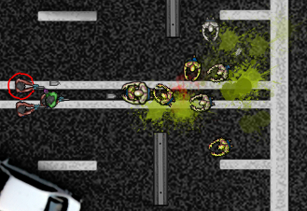

## Interaction with Horde and Enemies

The zombie king and enemies cannot occupy the same space simultaneously.

The zombie king and other zombies do not collide and can occupy the same space. When occupying the same space, the zombie king sprite covers the other zombie sprites.

## Game State Control

* Pause game (P key)
* Volume up (+ key)
* Volume down (- key)
* Mute (0 key)

# Zombie Horde

## Overview

The zombie horde is made up of individual zombies that are spawned after the player kills an enemy. Each zombie functions as a weakened version of the player, with less health and damage dealt. The zombie horde is under the control of the player, see Player Actions for how the player controls the horde.

## Zombie Horde Rules and Attributes

### States

Each zombie is in one of two states: Attacking or Defending

* Attacking: If the zombie does not currently have a target enemy, select the enemy with the closest Euclidean distance to the zombie. The zombie then walks towards its target, attacking if the enemy is within 40 pixels of the zombie.
* Defending: The zombie picks a random point near the player and walks towards it, picking a new point every two seconds. This is done to prevent the zombies from bunching up. The zombie will transition to the attacking state if an enemy comes within 50 pixels of the zombie, returning to the defending state after that enemy dies.

Attack

The zombie will attack its target one per second, when the target is within range.

#### **Visual**

When the zombie attacks, the zombie sprite animates through three frames at seven frames per second.

[](https://sites.google.com/site/zombiekingproject/home/zombie-horde/minion.png?attredirects=0)

When a bullet hits the zombie, the one of the two zombie blood splatter visual assets is displayed at the point of contact (chosen at random).

[](https://sites.google.com/site/zombiekingproject/home/zombie-horde/zombie_blood.png?attredirects=0)

[](https://sites.google.com/site/zombiekingproject/home/zombie-horde/zombie_blood2.png?attredirects=0)

#### **Attack Range**

The zombie attacks its current target when it is within 40 pixels, dealing only to that target.

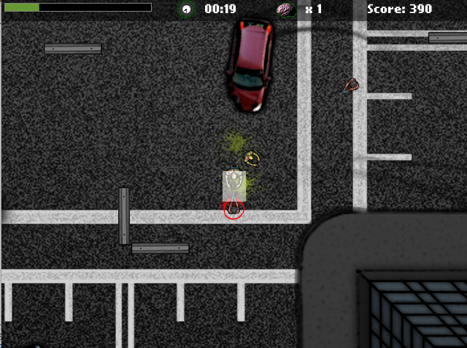

#### **Damage**

With each attack, the zombie deals 25 damage to the enemy.

#### **Enemy Death**

When the enemy is killed, each minion and the player receives 40 health, divided by the number of zombies (including the player) in the game. Unlike the player, no new zombie is spawned here.

## Visual

### Health Indicator

The zombie sprite is the same as the zombie king sprite, though smaller at 32x32 pixels. Each zombie is colored based on its current health, with different colors for 66 - 100 health, 33 - 66 health, and 0 - 33 health.

[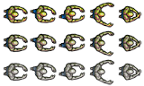](https://sites.google.com/site/zombiekingproject/home/zombie-horde/3_stage_zombie.png?attredirects=0)

### Corpse

When the zombie dies, a dead zombie image is placed where the zombie was. After 7.5 seconds, the corpse is removed from the game.

[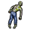](https://sites.google.com/site/zombiekingproject/home/zombie-horde/deadZombie.png?attredirects=0)

## Audio

### Attack

Each time the zombie attacks, there is a 34% chance that an audio clip will play. One of five audio assets are played.

### Being Attacked

When the zombie is hit by an enemy's bullet, there is a 34% chance that an audio clip will play. One of four audio assets are played.

### Death

When the zombie dies, one of four death audio assets will play.

# Enemies

## Overview

An enemy in Zombie King is a human offensive force whose purpose is to do damage to the player and Zombie Horde until the player dies (loses all of his health). Enemies interact with the environment, other enemies, the player, and the player's zombie horde.

Enemies are dispersed in waves (much like tower defense game waves) from the outer edges of the environment.

There are three types of enemies in Zombie King. Each of the enemy types has different rules and attributes that create distinct behaviors.

## General Enemy Rules & Attributes

Although there are several different types of enemies, they all share common rules and attributes.

### Purpose

The purpose of all enemies in Zombie King is to do damage to the player and his or her zombie horde.

### Method of Dealing Damage

All enemies deal damage to the player by hitting him with bullets fired intermittently in his direction.

### Audio

When a bullet hits the player or the members of the zombie horde, the bullet hit audio plays for one loop.

### Visual

When a bullet hits the player or members of the zombie horde, the blood splatter visual asset is displayed at the point of contact.

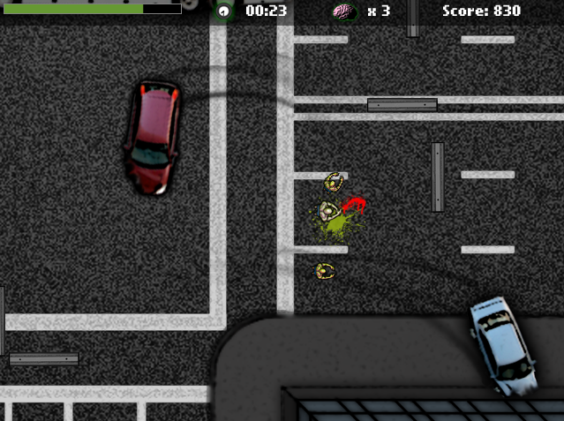

[](https://sites.google.com/site/zombiekingproject/home/enemies/blood2.png?attredirects=0)

[](https://sites.google.com/site/zombiekingproject/home/enemies/blood.png?attredirects=0)

### Engagement State

The enemy's state is determined by the proximity to the nearest zombie. There are four states**: in-pursuit**, **firing-in-pursuit**, **holding**, and **retreating**.

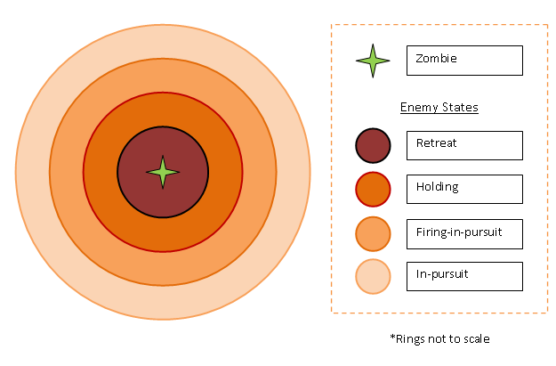

* **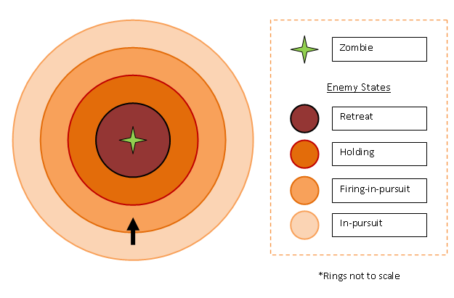In-pursuit**: The enemy is in-pursuit when the current target is outside of the firing radius. It approaches the target's position until the target is within the firing radius.

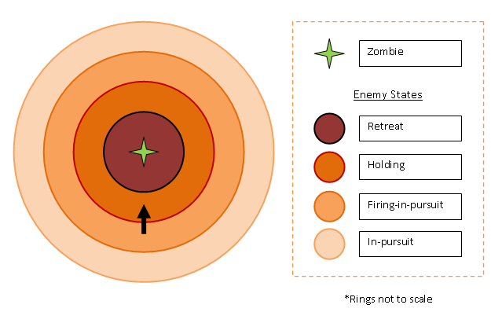

* **Firing-in-pursuit**: The enemy is firing-in-pursuit when the current target is within the firing radius but further than the hold radius. In this state, the enemy approaches the target's position and also fires at the target.

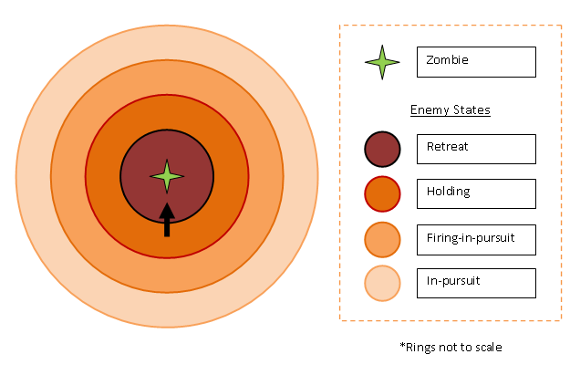

* **Holding**: The enemy holds position when the current target is within the hold position radius but outside the retreat radius. The enemy does not move and continues to fire at the target.

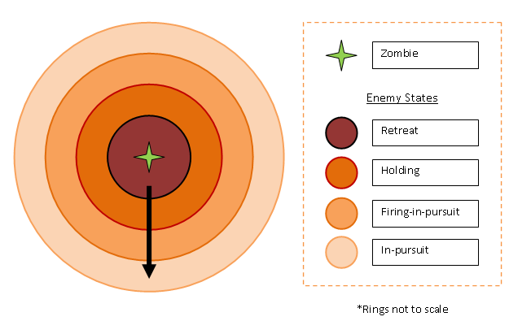

* **Retreating**: The enemy begins to retreat when the current target is within the retreat radius. The enemy runs directly opposite the target until it gets to the in-pursuit radius. It will then turn around, and approach the target.

### Velocity

Enemies move in a constant velocity in the direction defined by the enemy's current state. The constant velocity of the enemy depends on the specific enemy type.

### Path Finding & Walls

While moving to engage the current target, the enemy will find the shortest path between it and the target, factoring in obstacles and walls. While retreating, the enemy is scared and short-sighted, therefore, it will not avoid walls or obstacles. If it is up against a wall and the target is nearby, it will stay there and fire at the target until either it or the target is dead.

### Interaction with Other Enemies

Enemies do not coordinate with other enemies. Enemies block each other; no two enemies can occupy the same space. Bullets will pass through other enemies without effect.

### Damage Absorption

When an enemy and a zombie engage in melee combat, the zombie can deal damage to the enemy. The damage is decremented from the enemy's health. When the enemy's health drops to zero, the enemy dies, and its sprite is removed from the level. Each enemy type has a different starting health, and this health cannot be recovered. When an enemy is hit by a zombie, a visual cue appears beneath it.

### Visual Cue



## Definitions of Enemy Types

### Overview

The enemy types vary across these attributes:

* Firing time intervals: The time in between each shot fired by the enemy.
* Bullet speed: The speed at which the bullet moves towards the zombie's position
* Damage dealt: The amount of health subtracted from the zombie when the bullet hits.
* Firing radius: The distance at which the enemy can fire bullets in the zombie's current direction.
* Retreat radius: The distance at which the enemy will run away from the zombie.
* Health: The amount of damage the enemy can take before it dies.

|  |  |  |  |
| --- | --- | --- | --- |
|  | **Regular Cop** | **Cautious Cop** | **Fearless Cop** |
| Firing time interval | 1.5 sec | 1.5 sec | 1.5 sec |
| Bullet speed | 200 px/sec | 200 px/sec | 200 px/sec |
| Damage dealt | 10 hp | 10 hp | 10 hp |
| Firing radius | 250 px | 250 px | 250 px |
| Retreat radius | 100 px | 150 px | 0 px |
| Health | 100 hp | 100 hp | 100 hp |
| Speed | 75 px/sec | 75 px/sec | 75  px/sec |
| Sprite | [https://sites.google.com/site/zombiekingproject/_/rsrc/1292608762325/home/enemies/cop_frame.png](https://sites.google.com/site/zombiekingproject/home/enemies/cop_frame.png?attredirects=0) | [https://sites.google.com/site/zombiekingproject/_/rsrc/1292608726088/home/enemies/cop3_frame.png](https://sites.google.com/site/zombiekingproject/home/enemies/cop3_frame.png?attredirects=0) | [https://sites.google.com/site/zombiekingproject/_/rsrc/1292608753434/home/enemies/cop2_frame.png](https://sites.google.com/site/zombiekingproject/home/enemies/cop2_frame.png?attredirects=0) |

# Waves

## Overview

Enemies spawn in waves. A wave is defined by:

* Frequency of enemies spawned
* Distribution of enemy types
* Two minute duration

## Spawning Zones

During a wave, enemies spawn from areas located on the north, south, east and west edges of the environment.

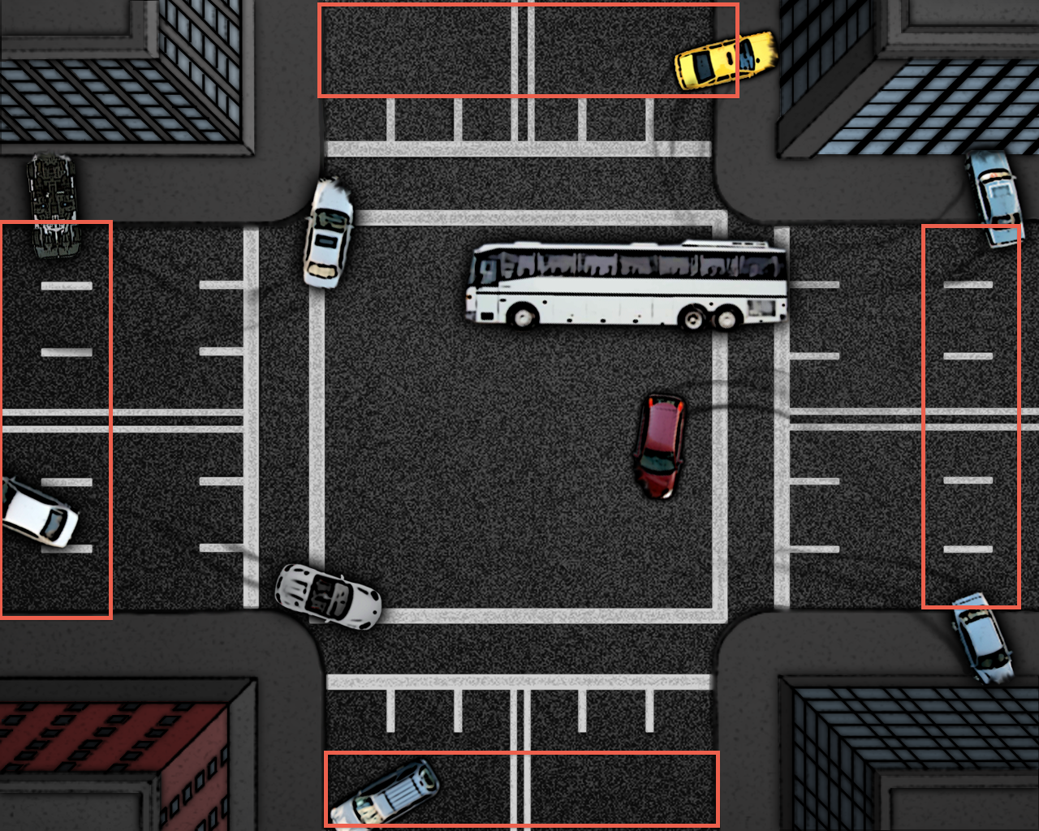

The enemy spawns at a random point within the spawning zone.

## Difficulty Progression

Over the duration of a single wave, difficulty increases. In addition, each subsequent wave the player engages is increasingly challenging.

### Intra-Wave Difficulty Progression

The rate at which enemies spawn in a given wave increases linearly.

### Inter-Wave Difficulty Progression

At the end of a wave's duration, a subsequent wave begins. Each subsequent wave the player survives increases in difficulty in the following ways:

* The likelihood of spawning more challenging enemy types increases. For example, the likelihood that a Fearless Cop will spawn decreases, while the likelihood that a Cautious Cop will spawn increases.
* The total number of enemies spawned in the wave increases.
* As more enemies spawn, the likelihood that the player will kill all enemies in the duration of the wave decreases. Enemies left over at the end of the wave will continue to attack the player in the next wave, thus increasing the total enemies.

# Scoring System

The player is scored by three metrics:

* Number of enemies killed (brains consumed) by the player
* Number of enemies killed by the player's minions
* The time survived

The metrics are combined to a final score by this formula:

Score = (Player brains) \* 200 + (Minion brains) \* 100 + Seconds survived \* 10

At the end of the game, a score screen is displayed, giving the totals of the three metrics. See Game Flow for the score screen view.

The metrics are displayed during the game in the HUD.

# HUD

## Overview

The HUD is the area in the game UI that shows the player his progress, scores, and health.

## HUD Elements



1. Health
2. Survival Time
3. Total number of enemies killed (brains consumed)
4. Score

# Environment Features

## Overview

The map is a depiction of a desolate cityscape that is cluttered with overturned cars, wreckage and roadblocks. The map is an area defined by a rectangle that’s dimension is 1280 x1024. From a player’s perspective, only a 640x480 rectangle is viewable at any time. The player’s viewport cannot extend beyond the map.

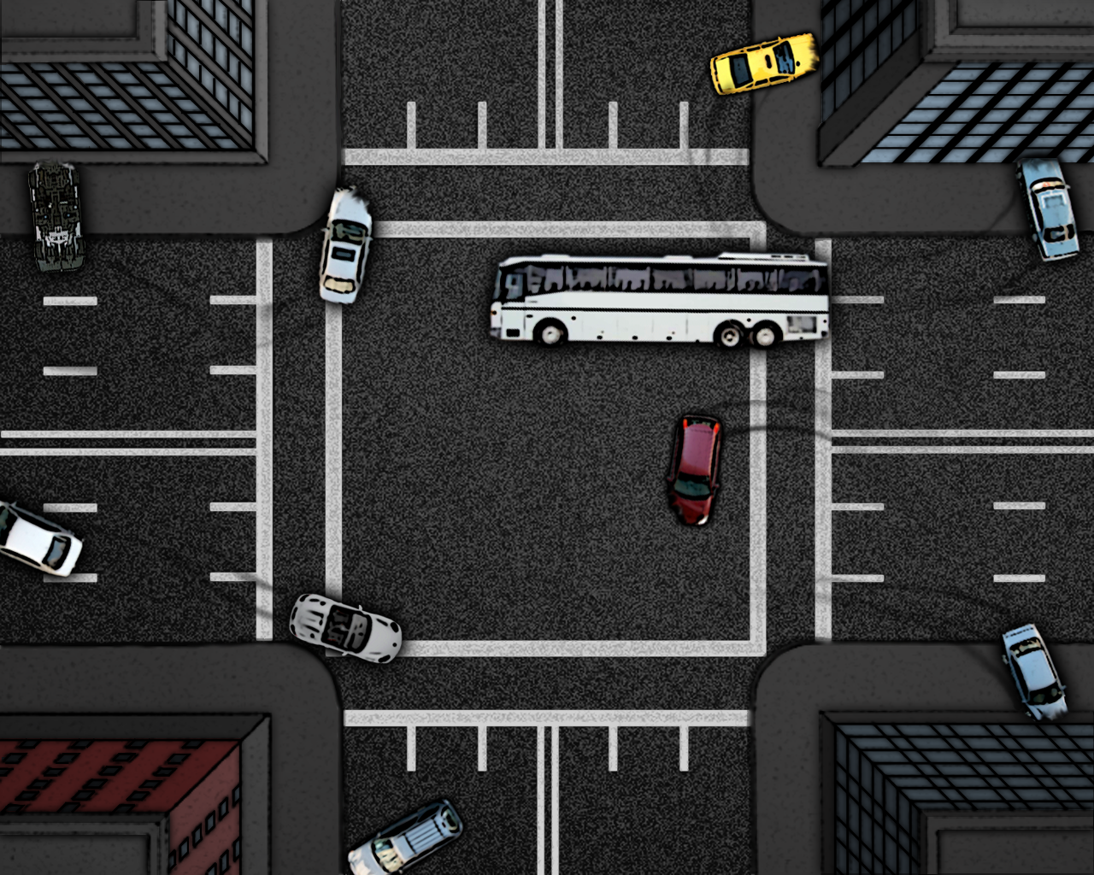

## Map features

The map contains many colliders that hinder the movement of the player and enemies alike. The colliders are placed such that players and enemies cannot move through cars, buildings or road blocks. The map is a closed environment. No sprites can leave the scene.

## Camera

The camera remains centered above the player at all times. If the player approaches the sides of the map, the camera remains at a distance such that the viewport does not extend passed the side of a map.

# Audio Assets

## Cop Audio

### Takes Damage

When a cop is hit by a zombie the one of the following audio clips is played at random:

* cop\_hi1.mp3
* cop\_hit2.mp3

### Death

When a cop dies, one of the following audio clips is played at random:

* cop\_die1.mp3
* cop\_die2.mp3

## Zombie Audio

### Attack

When a zombie (either the player or member of the horde) attacks, one of the following audio clips is played at random:

* zombie\_attack1.mp3
* zombie\_attack2.mp3
* zombie\_attack3.mp3
* zombie\_attack4.mp3
* zombie\_attack5.mp3

### Takes Damage

When a zombie take damage from an enemy, one of the following audio clips is played at random:

* zombie\_hurt1.mp3
* zombie\_hurt2.mp3
* zombie\_hurt3.mp3
* zombie\_hurt4.mp3

### Death

When a zombie dies, one of the following audio clips is played:

* zombie\_die1.mp3
* zombie\_die2.mp3
* zombie\_die3.mp3

### Spawn

When a zombie minion spawns, one of the following audio clips is played:

* zombie\_moan1.mp3
* zombie\_moan2.mp3
* zombie\_moan3.mp3

# Visual Assets

3\_stage\_zombie.png

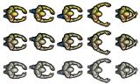

blood.png



Blood2.png



Brain.png



Clock.png



Cop1.png

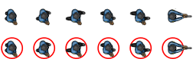

Cop2.png

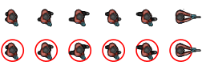

Cop3.png

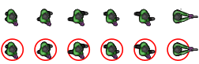

Corpse.png

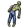

map1.png

attack\_animation.png



Road\_block\_h.png



Road\_block\_v.png



Attack\_animation2.png



Blood\_z1.png



Blood\_z2.png



Bullet.png



# Technical Design Overview

## Overview

The core technical improvements we need to make mostly involved tuning, tweaking and advancing zombie horde and enemy AI. Currently, we lack path finding and obstacle avoidance both of which are high priority changes we need to make in the next version.

## Big Issues

### Collisions

Several issue we encountered centered around the game framework we selected (Flixel). Flixel does not implement pixel perfect collision detection and instead relies on bounding box intersection. Furthermore, the bounding box intersection Flixel uses relies on bounding boxes oriented with the primary axes. This forced us to change our map in order to have collisions work correctly. All of our obstacles in our map were rotated so that they were aligned with the primary axes.

### Path Finding and Obstacle Avoidance

Another issue we came across in the implementation of the AI for the game involved path finding and obstacle avoidance. The two places this manifested most were when members of the zombie horde pursue enemies, and when human enemies pursue zombies. In the current naive implementation of the pursuit code, the pursuer simply runs in the direction of his target. In future releases, we intend to implement obstacle avoidance and path planning. The algorithm we selected for path planning and obstacle avoidance is called Tangent Bug.

Tangent bug begins with the pursuer moving towards a goal point. If an obstacle is hit, the pursuer begins to circumnavigate the obstacle in a predefined direction. When the pursuer reaches a point on the perimeter of the obstacle that no longer blocks the direct path to the goal point (ie the target) it begins moving in the direction of the target again. This algorithm was selected because it uses knowledge local to the character and does not require any global knowledge of the game state other than the target position. This is important so as to keep performance of the game at a level such that the frame rate remains within reasonable limits.